**Identifying Optimal Locations To Open a Chinese Restaurant in Dublin**

**PART 1**

**Background & Business Problem**

***Business Problem***

"Would you recommend a location in Dublin to open a new Chinese restaurant? "

In this project, the selection of the locations is assumed to be highly dependent on its nearby environment instead of the economic factors such as rental prince. The main task would be to select the 5 possible locations to open the cinema and explain them to stakeholders.

***Data Sources***

* centers of candidate areas will be generated algorithmically and approximate addresses of centers of those areas will be obtained using Google Maps API reverse geocoding;
* number of restaurants and their type and location in every neighborhood will be obtained using Foursquare API;
* coordinate of Dublin center will be obtained using Google Maps API geocoding of well-known Dublin location.

**PART 2**

**Analysis Process**

***Step 1 City Centers***

We will first find the latitude & longitude of Dublin city center, using specific, well-known address and Google Maps geocoding API.

***Step 2 Restaurants***

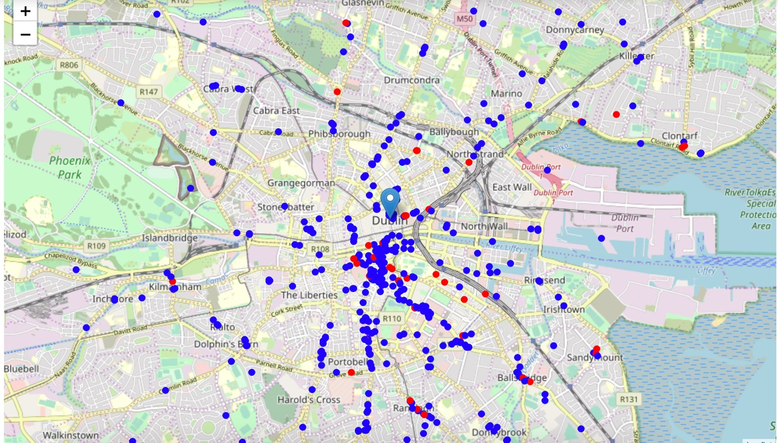

After obtaining the longitudes and latitudes of each area, it is necessary to go over these neighborhood locations and get nearby restaurants. In addition, we will maintain a dictionary of all-found restaurants and all-found Chinese restaurants.

***Step 3 Optimal Locations***

It is necessary to create a map showing heatmap / density of restaurants and try to extract some meaningful information from that. A few circles are plotted to indicate distance of 1km, 2km and 3km from N Earl St.

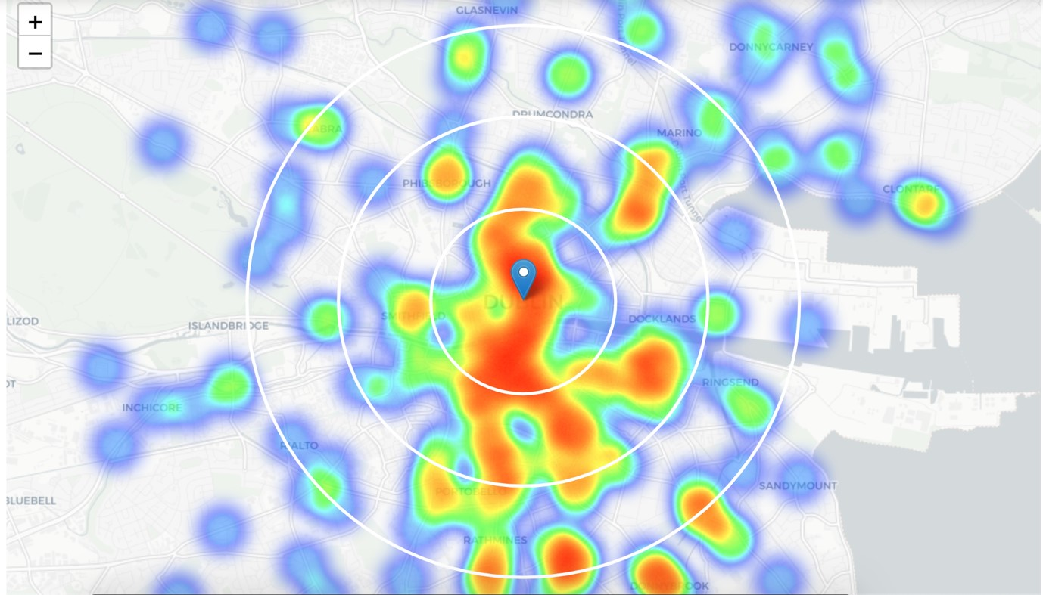

***Step 3 Optimal Locations (Chinese Restaurants)***

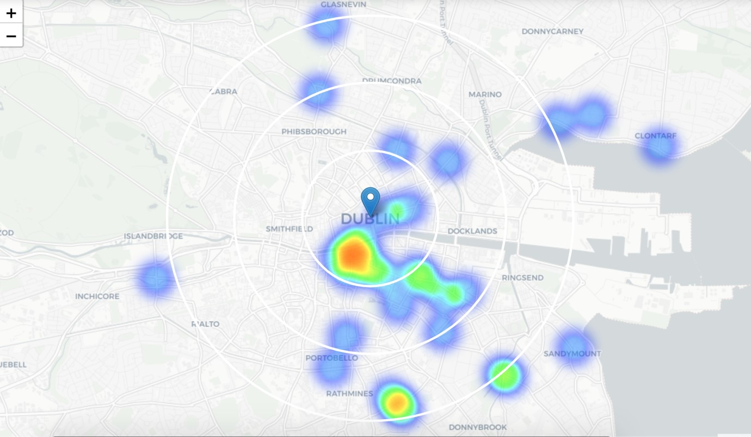

As you can see from the map above, • It is not so 'hot' which means Chinese restaurants represent a subset of approximately 10% of all restaurants in Dublin, • It also indicates higher density of existing Chinese restaurants directly south from N Earl St.

***Step 3 Optimal Locations (Area of Interest)***

Let's define new, narrow region of interest, which will include low-restaurant-count parts.

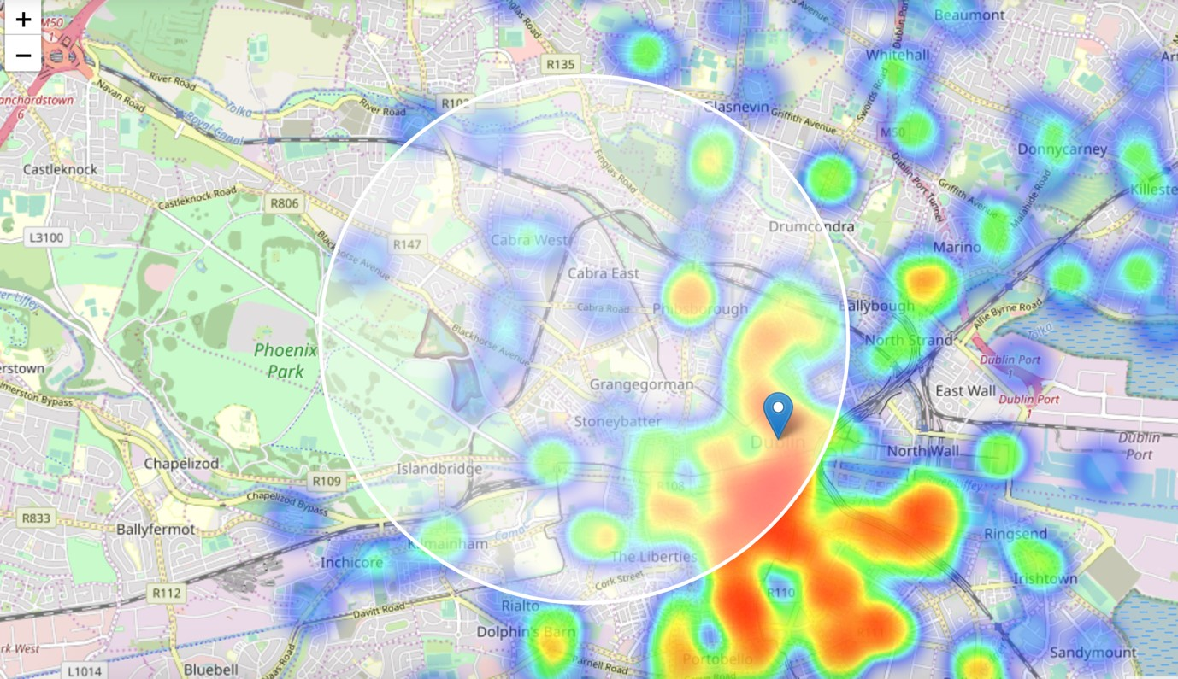

***Step 3 Optimal Locations (Area of Interest)***

Based on the filtering criteria:

• locations with no more than two restaurants in radius of 250 meters,

• no Chinese restaurants in radius of 400 meters.

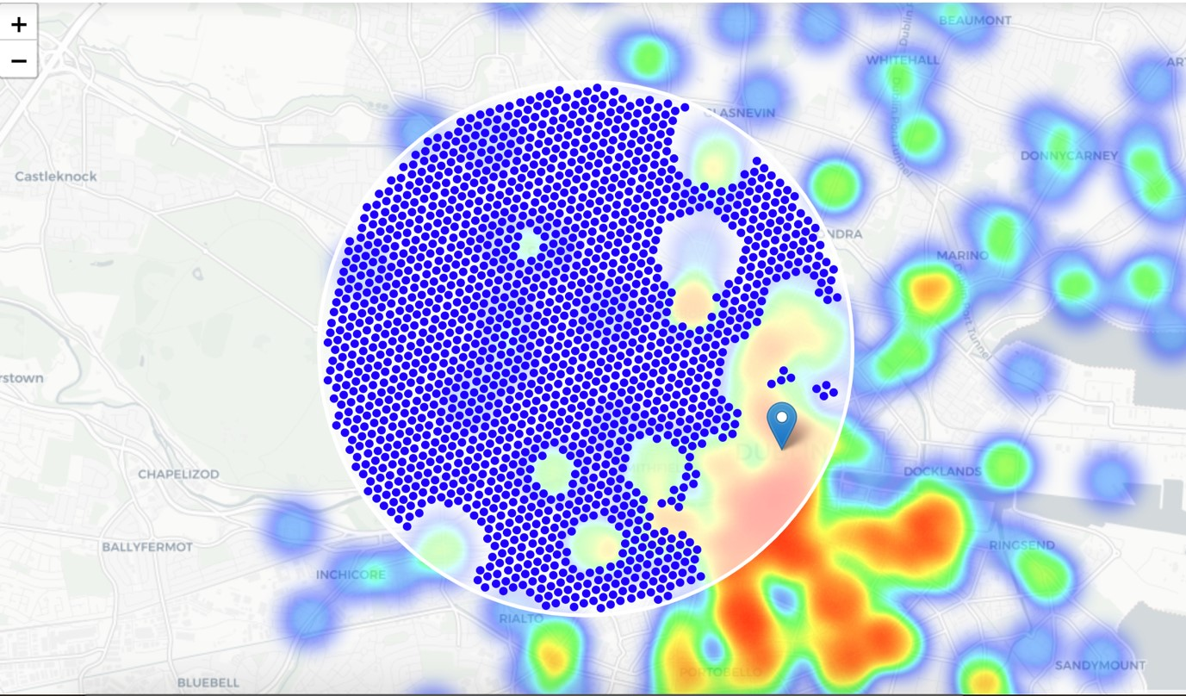

The results are shown as follows:

* Locations with no more than two restaurants nearby: 1884
* Locations with no Chinese restaurants within 400m: 1928
* Locations with both conditions met: 1737

**Clustering**

Clustering The final step is to cluster those locations to create centers of zones containing good locations. Those zones, their centers and addresses will be the final result of our analysis.

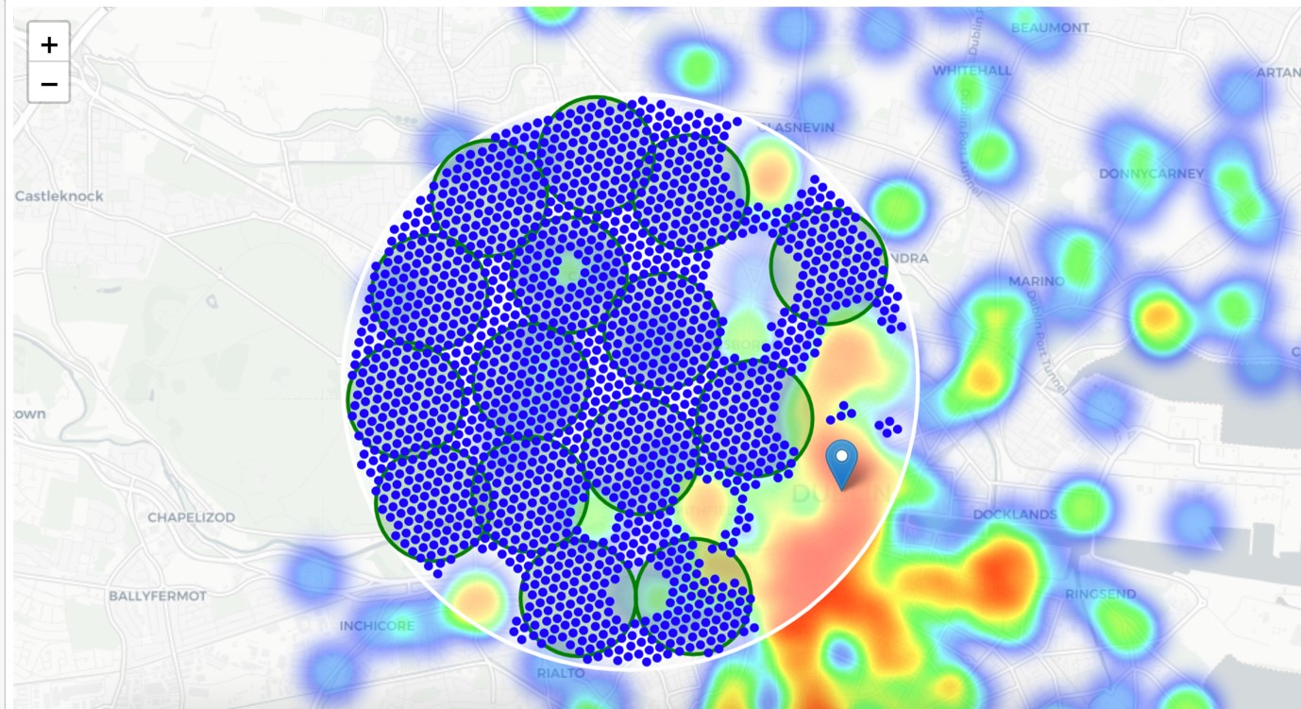

**Results & Conclusions**

***Results***

The final things is to reverse geocode those candidate area centers to get the addresses which can be presented to stakeholders.

1 Glasnevin Ct, Cabra East, Dublin 11, D11 A6X2 => 3.7km from N Earl St

Phoenix House, Phoenix Park, Dublin 8, Co. Dublin => 2.8km from N Earl St

Saint Anthony, Inver Rd, Cabra West, Dublin 7 => 3.1km from N Earl St

16 Cuala Rd, Cabra East, Dublin 7, D07 NW52 => 2.1km from N Earl St

12 Crawford Ave, Drumcondra, Dublin 9, D09 K5Y8 => 2.0km from N Earl St

6A Wilson's Terrace, Merchants Quay, Dublin, D08 E8P => 1.6km from N Earl St

16a Dunard Rd, Cabra West, Dublin 7, D07 Y5W0 => 2.9km from N Earl St

1 Auburn St, Phibsborough, Dublin 7, D07 A7Y7 => 1.0km from N Earl St

52 Navan Rd, Villa Park Rd, Ashtown, Dublin 7, D07 X5XY => 4.1km from N Earl St

12 Ostman Pl, Arbour Hill, Stoneybatter, Dublin, D07 E0E6 => 1.8km from N Earl St Marian School, Cabra West, Dublin, Co. Dublin => 4.1km from N Earl St

Chesterfield Ave, Phoenix Park, Dublin => 4.0km from N Earl St

The Willows, Botanic, Dublin, Co. Dublin => 3.0km from N Earl St

St. James's Hospital, Dublin 8, James's Street => 2.5km from N Earl St

Glacis Cottage, Military Rd, Phoenix Park, Dublin 8 => 3.6km from N Earl St

***Conclusions***

Result of all this is 15 zones containing largest number of potential new restaurant locations based on number of and distance to existing venues - both restaurants in general and Chinese restaurants particularly. Final decision on optimal restaurant location will be made by stakeholders based on specific characteristics of neighborhoods and locations in every recommended zone, taking into consideration additional factors like attractiveness of each location (proximity to park or water), levels of noise / proximity to major roads, real estate availability, prices, social and economic dynamics of every neighborhood etc.